Modelagem de dados

* Modelo conceitual

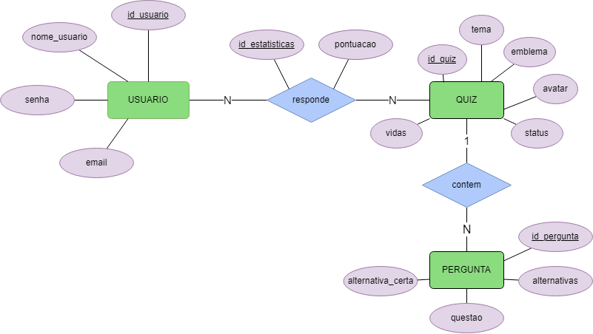

* Modelo lógico

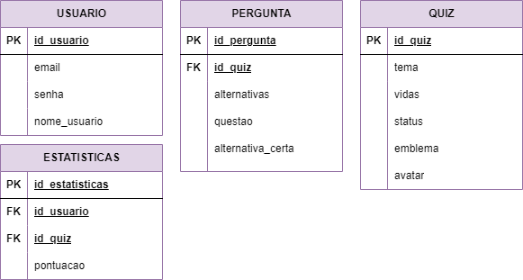

create database hfashion;

commit;

use hfashion;

create table users (

id int auto_increment primary key,

email varchar(45) not null unique,

password varchar(20) not null,

nickname varchar(45) not null,

bio varchar(200),

image VARCHAR(100),

token VARCHAR(100)

);

create table quiz (

id_quiz int auto_increment primary key,

tema varchar(50) not null,

vidas int(1) not null,

status int not null,

emblema varchar(50),

avatar varchar(50)

);

create table estatisticas (

id_estatisticas int auto_increment primary key,

id_usuario int not null,

id_quiz int not null,

pontuacao int not null

);

create table pergunta(

id int primary key AUTO_INCREMENT,

alternativas varchar(70) not null,

questao varchar(300) not null,

alternativa_certa int not null,

id_quiz int not null

);

alter table estatisticas add CONSTRAINT fk_usuario FOREIGN KEY (id_usuario) references users(id);

alter table estatisticas add CONSTRAINT fk_quiz_estatic FOREIGN KEY (id_quiz) references quiz(id_quiz);

alter table pergunta add CONSTRAINT fk_quiz FOREIGN KEY (id_quiz) references quiz(id_quiz);

select * from quiz;